***A CONSTRUÇÃO DA GOVERNABILIDADE DA ÁGUA NO CEARÁ:***

***AVANÇOS E DESAFIOS APÓS QUATRO DÉCADAS DE REFORMAS***

***CONSTRUCTING WATER GOVERNABILITY IN CEARÁ:***

***ADVANCES AND CHALLENGES AFTER FOUR DECADES OF REFORMS***

**Resumo**

O modelo de gestão dos recursos hídricos no estado do Ceará vem sendo muito estudado e elogiado, sobretudo no que concerne à governança, considerada particularmente participativa e integrada. Entretanto, esse modelo, cujos contornos básicos foram estabelecidos entre 1987 e 1993, também inclui um projeto de *governabilidade*. A democratização da gestão foi concebida como um instrumento que permitisse melhor conhecer, controlar e direcionar os usos da água por parte das agências do estado, em suas diversas escalas. Após três décadas de implementação das reformas, que avaliação pode ser feita desse projeto de governabilidade por meios democráticos? Neste artigo, sustenta-se o argumento de que o sistema de governança foi, de um lado, fundamental para o aprimoramento de uma governabilidade hídrica em nível “meso” das bacias hidrográficas; mas, de outro, foi muito menos favorável à construção de uma governabilidade “micro”, ou seja, em nível local. Atribuímos esses efeitos ambivalentes a dois mecanismos. Primeiramente, a implementação do modelo suscitou problemas e gerou debates referentes sobretudo à organização institucional das bacias hidrográficas que, por consequência, monopolizou constantemente a atenção dos atores envolvidos, em detrimento dos desafios que se apresentam em nível local. Em segundo lugar, interpreta-se que o modelo acarretou a marginalização do papel dos municípios, embora permaneçam atores incontornáveis para o estabelecimento de uma governabilidade local da água. Assim, destacam-se dois efeitos inesperados da governança sobre a governabilidade: a monopolização da atenção e a marginalização de um ator influente. Na medida em que tais efeitos poderiam acabar desestabilizando o próprio modelo de governança, os mesmos são aqui conceitualizados como *feedbacks* ‘negativos’ da ação pública. O artigo contribui para sua identificação e análise. Em conclusão, argumenta-se que somente formas mais inclusivas e deliberativas de governança em nível local poderão melhorar a governabilidade nessa escala e, assim, abrir uma nova etapa para o "modelo cearense".

**Palavras-chaves**: recursos hídricos, governança, governabilidade, efeito *feedback*.

**Abstract**

The management of water resources in the state of Ceará, Brazil, has been widely analyzed and praised for its governance, commonly regarded as remarkably participatory and integrated. However, this model, whose essential contours were designed between 1987 and 1993, also included a *governability* project. The democratization of governance was conceived, by state agencies, as an instrument to better know about, control, and guide water uses at different scales. Nearly four decades after this critical juncture, what assessment can be made of this governability project through democratic governance? In this paper, we argue that governance arrangements were, on the one hand, fundamental to furthering water governability at the “meso” level of watersheds; but, on the other hand, that they were much less conducive to strengthening governability at the more "micro", local level. We attribute these ambivalent effects to two mechanisms. First, the implementation of the model raised many difficult issues related to the institutional organization of watersheds, which consequently monopolized stakeholders’ attention, to the detriment of the challenges that emerged at the local level. Second, governance arrangements eventually confined municipalities to a subordinate role, even though local governments remain indispensable actors to advance local governability. Thus, we foreground two unexpected effects of governance on governability: the monopolization of attention and the marginalization of an influential actor. To the extent that weak local governability may end up destabilizing the current governance architecture itself, we conceptualize these two effects as potentially ‘negative’ policy feedbacks, which the paper thus contributes to identify. In conclusion, we argue that only more inclusive and deliberative forms of governance at the local level may further the local governability of water resources, thereby opening a new stage for the "Ceará model".

***Keywords*:** water resources, governance, governability, feedback effects.

# ***Introduction***

Since the early 1990s, the state of Ceará has been widely praised by international institutions, such as the World Bank, for its pioneering efforts to implement an “integrated” and “participatory” management of water resources. The most emblematic collegial bodies are the Water Resource Management Committees (WRMC) and the Management Commissions. Both are made up of water users, representatives of organized civil society, and representatives of public authorities. The 12 committees are responsible for planning water resources and their uses at the level of river basins and sub-basins (Ceará, 2018). The 83 commissions, in turn, are approved by the committee of their region. Their main responsibility are to carry out a “negotiated allocation of water,” an annual and participatory process of allocation for a reservoir and a section of river. More precisely, commissions are set up for reservoirs and water systems that regularize the flow of a major river, with implications for regional development (Frota *et al.*, 2013). These two sites of participation[1] are commonly presented as sites of partnership between the state and society (Lemos & Oliveira, 2005).

These arrangements did not indicate any retrenchment, on the part of the state of Ceará, from a central role in resource management. Rather, the reform process involved the creation of two new state bureaucracies crucial to asserting its authority. The first of these was the Secretariat of Water Resources (SWR), established in 1987 with the mission of promoting a more integrated use of the state's water resources (SWR, 2022). Shortly thereafter, in 1993, and under the authority of the former, another central institution was established: the Water Resources Management Company (COGERH), responsible for implementing participatory management through the organization and mobilization of members of Water Resource Management Committees, water users, and other interested groups. Furthermore, the Cearense Foundation for Meteorology and Water Resources (FUNCEME) became part of the SWR and became the institution dedicated to monitoring water resources in the state and producing data to support decision-making, especially in the negotiated allocation of water resources.

In this way, the model aimed to strengthen, through the democratization of governance, the *governability* of water resources by the state (Taddei, 2011). Governability, here, is understood as “the general capacity to control and regulate a socio-natural entity or system” (Kooiman, 2008, p.3). Unlike the concept of governance, which relates to the allocation of roles and responsibilities, governability refers to the implementation capabilities of the decisions taken. It denotes the effective capacity to “[...] intervene and shape a phenomenon according to goals, through the instruments that are available” (TA, 1993, p. 13). In this case, in a tumultuous context marked by the intensification of water uses across various sectors, a process of political and administrative municipalization, and the state reclaiming prerogatives that had previously been federal, the democratization of water management was not only seen by state elites as an end in itself but also as a tool that would enable them to better know about, control, and guide water uses at various scales (Taddei, 2011). The new model aimed to decentralize implementation and decision-making while centralizing the coordination of public policy in the hands of the state government, a dual movement described by Tendler (1998) as a “paradox of decentralization.”

After three decades of implementing reforms, what assessment can be made of this project of governability through democratic governance? Contrary to what state reformers had hoped for, numerous empirical observations indicate that the vast majority of small and medium-sized reservoirs remain unmonitored to this day, and that water usage tends to be poorly understood and, consequently, inadequately regulated by the state of Ceará through the current permitting system. A recent report commissioned by the State Government, as part of a bilateral cooperation with France on water management, emphasizes that “[...] the State Water Resources Management System lacks local-level capillarity, and this has repercussions on the improper use of water, the proliferation of irregular withdrawals upstream of reservoirs (damming, wells, irrigation), that compromise the water availability of strategic systems” (Burte *et al.*, 2020, p. 90). FUNCEME observers also describe a proliferation of small reservoirs that are being built without regulation. This lack of local governance harms the environmental sustainability of river basins, which is already under serious threat in the semi-arid region of Ceará, as well as in many river basins in the Brazilian Northeast (Medeiros *et al*., 2023). In fact, it threatens to destabilize the governance system itself, potentially undermining its legitimacy and reducing its ability to manage conflict.

Such a threat of a governance crisis, caused by persistent limitations in water governability, can be conceptualized, in political science terms, as a matter of “negative policy feedback” (Weaver, 2010; Mettler & Sorelle, 2018; Schmid *et al*. , 2020). This notion refers to all policy consequences, typically unintentional, that tend to undermine, rather than reinforce, its political, fiscal, or social sustainability (Weaver, 2010). Generally speaking, the ability to avoid, limit or absorb negative feedbacks is an important factor in the durability of any governance system (Hacker & Pierson, 2019). Therefore, it is important to assess whether the observed governability deficit could be managed by the current system of water governance, or whether it justifies its reform.

From an empirical standpoint, the objective of this article is to understand the persistent challenges of the governance model in the state of Ceará in establishing robust local governability of water resources. In so doing, the intention is to devote more attention on the implementation capacity of the model, as this discussion appears to have largely remained in the background compared to the primary emphasis placed on the quality of social participation. Our underlying assumption is that continually deepening the democratic and participatory nature of the system will not lead to commensurate improvements in water management if the decisions made do not have the necessary conditions for effective and systematic implementation.

Our argument is that while the governance system played a crucial role in enhancing water governability at the river basin level, it did not facilitate the development of local-level governability. We attribute what is, from the perspective of the state government, a disappointing outcome, to two mechanisms. First and foremost, the implementation of the model brought forth issues, and sparked debates, primarily regarding the institutional organization of river basins, which consistently monopolized stakeholders’ attention, at the expense of water dynamics at the local level. Secondly, the model gave only a secondary role to municipalities, even though they remain essential in effecting local water governability. Thus, we foreground two unexpected effects of governance on governability: the monopolization of attention and the marginalization of an influential actor. As these effects could potentially destabilize the governance model itself, they can be regarded as negative policy feedback which this article thus contributes to identifying and analyzing.

This article is organized into seven parts. After this introduction, a second part develops our theoretical framework based on the notions of governability and policy feedbacks. The third part outlines the methodology used, highlighting its collective and participatory dimension. The fourth describes the growing gap between a more robust governability at the basin level and a governability that remains irregular and fragile at the local level. The fifth part highlights the process of monopolization of attention due to governance issues at the level of basins and large valleys, favoring the negligence of the local level. The sixth part describes the gradual marginalization of municipalities in the functioning of the arrangements and its negative effects on the capacity for local governance. The seventh part is the conclusion.

# ***From governance to governability… and back: a theoretical framework***

The notion of governability has its origins in a context of the reaffirmation of conservative political trends, which explains its initial lack of success in the social sciences. It developed with the work of Huntington in the late 60s and early 70s (cf. Huntington, 1968; 1975). At a time of global social unrest, the American political scientist feared that excessive social demands would make state action more difficult, leading governments to take too many decisions that were overly ambitious and, therefore, difficult to implement. Thus, Huntington diagnosed the risk of a “crisis of governability” in modern societies, caused by the excessive proliferation of social and economic demands on governments.

However, this notion has gradually emancipated itself from its conservative origins. It now refers, in a less politically charged way, to the “[...] capacity of a power structure to effectively implement plans and programs in the face of the social and economic demands present in the governed environment” (Pereira Júnior, 2008, p. 521). At this point, it is worth highlighting the relational character of the concept. Governability does not depend only on the resources that the actors of a governance system possess, which is what the literature on “state capabilities” often tends to assume (Cárdenas, 2010). Rather, governability depends on both the qualities of the subject (the governance system) and the attitudes of the object of governance (the system to be governed), and the relationship between the two (Kooiman *et al*., 2008). In other words, both the governing authorities, the governed population, and their interactions collectively contribute to governability. Far from being a fixed state, governability is an interactive process through which a socio-natural object becomes more or less governable (Song *et al*., 2018).

The governability of a phenomenon therefore depends on multiple and heterogeneous dynamics. Among them, the ability of governance systems themselves to reinforce - or undermine - governability over time stands out. An important causality can then unfold in two stages: governance determines governability, which in turn determines the durability of governance.

In this regard, it should be noted that historical institutionalism in political science generally emphasizes the self-reinforcing processes of governance systems - in other words, positive feedback- which is among the foundations of the broader phenomenon of path dependence. (Pierson, 2004). Positive feedback is a process that increases the political, economic, or social benefits of a governance system (or the perception of such benefits) over time, and, as a consequence, progressively expands its social support (Jacobs & Weaver, 2015). Interestingly, one of the early perspectives on feedback emphasized the positive relationship between certain governance systems -or public policies- and governability. The argument put forth was that new policies tend to expand the fiscal and bureaucratic capacities of the state, thereby contributing to the process of state-building, which, in turn, facilitates the future construction of new public policies. This is because, as Skocpol (1992) argued, administrative arrangements are often necessary to implement new policies, which, in turn, reinforce the state's structures and capacities over time. Furthermore, bureaucratic actors favored by new policies can become more powerful, gaining increased influence in decision-making that they can use to push for an expansion in public policies in line with their interests and preferences (Béland & Schlager, 2019).

Gradually, however, it has been increasingly recognized that any governance arrangement tends to produce a combination of positive and negative feedback. According to Weaver (2010), negative feedback comprises endogenous effects that weakenthe political, fiscal, or social sustainability of an existing set of policies. They can take a variety of forms. For example, a policy may generate increasing costs over time. It may also generate growing opposition from certain groups who feel ignored or harmed by the current arrangements (Weaver, 2010). Negative feedbacks also occur when the accumulation of contradictory policies ends up harming their effectiveness (Adam *et al*., 2019). In these latter cases, it is the lack of governability which undermines the legitimacy of existing policies and governance systems.

Therefore, different types of feedback dynamics tend to occur at the same time, and the level of social legitimacy of any governance system, as well as receptivity to reform proposals , depends on each particular combination (Busemeyer *et al*., 2021). It is important to note, however, that the feedback issue has not yet been connected to issues of governance scales. In this respect, one of the contributions of this article is to show that feedbacks can be fundamentally different depending on the scale considered: a “positive” effect at the supralocal level can come alongside a “negative” effect at the local level.

This article identifies two negative feedback mechanisms between governance and governability: the monopolization of attention and the marginalization of an influential actor. The first corresponds to what Pierson (1993) calls an interpretation effect, as it affects stakeholders’ perception of the situation and of priorities; while the second corresponds to a resource effect, in which a certain distribution of resources and prerogatives by a governance system generates unexpected effects (Figure 1).



FIGURE 1 - Two unexpected effects of governance on governability.

SOURCE: Prepared by the authors.

# **3. *A participatory methodology***

This work is part of an action research project called *Sertões* - Water and Territorial Sustainability and Resilience in the *Sertões do Nordeste* -, a partnership between the French Center for International Cooperation in Agricultural Research for Development (CIRAD) and the Cearense Foundation for Meteorology and Water Resources (FUNCEME), with funding from the French Development Agency (AFD), from 2021 to 2024. The objective of the *Sertões Project* was to study territorial trajectories (past-present) around water resources and to co-construct, along with staleholders at different scales, new models of local water governance, integrated into a logic of water resilience and agroecological transition.

This article is the product of the multifaceted methodology that marked the evaluation phase of water governance trajectories by the *Sertões* project, with three main and complementary dimensions. The first was a bibliographical survey of around one hundred documents, including administrative reports, project evaluation documents, regulatory texts, planning documents, and academic papers. The second consisted of thirty interviews, carried out between April and December 2021, involving institutional actors and representatives of civil society and social movements. These interviews allowed us to identify different perspectives on current policies and governance systems and to delve into the specifics of water policies (their implementation, weaknesses, difficulties, inconsistencies, etc.). The third was the preparation, facilitation, and subsequent analysis of a series of field visits organized in November 2021, in the Banabuiú river basin, especially in the rural areas of the municipalities of Quixeramobim, Milhã, and Piquet Carneiro, which we called a “Field School”. In this context, a thematic group focused on the governance of water resources and carried out field visits and collective workshops on different types of reservoirs: small community reservoirs, large monitored reservoirs, and public reservoirs without formal management structures. These activities enabled exchanges with residents of the region and with members of various structures, in particular the COGERH, the municipal councils of Quixeramobim, Milhã, and Piquet Carneiro, the Landless Rural Workers Movement – MST- and local civil society organizations, such as the Institute for Art, Culture, Leisure, and Education - IARTE. The Field School therefore enabled more direct observations about the local scales of governance.

Although the central axis of the work is based primarily on bibliographical research, the other elements (group discussions, interviews, field visits, and participatory workshops) were crucial to validating (or questioning) the main hypotheses that we first raised. It is, therefore, a material that aims to understand and value different perspectives, reflecting the interest in promoting the participation of different interested groups, as well as the activation and mobilization of different state actors that are relevant to water governance. It should also be noted that the empirical analysis was carried out from a historical perspective. We started from the consideration that existing governance systems were the product of past historical junctures that guided their formation and meaning.

1. ***Uneven water governability***

At the end of the 1980s, in the context of the country’s redemocratization, the state of Ceará sought to strengthen water governance through participatory mechanisms, which are nowconsidered advanced in comparison to most other Brazilian states. As we will see, this democratization process has had uneven results in terms of governability: a clear strengthening at the river basin scale, but a weakening at the local scale.

## ***4.1. A project of democratic governance: the reformative juncture of 1987-1993***

Until the mid-1980s, the state of Ceará exercised secondary authority over water, which was managed mainly by the federal bureaucracy of the [National Department of Works Against Droughts](https://www.gov.br/dnocs/pt-br) - DNOCS. Tasked with storing water in reservoirs as a response to droughts made DNOCS the main federal body executing and managing water resources in the state. Being also responsible for infrastructure projects such as roads, railways, energy, and other water sources like wells and reservoirs, sometimes built on private land, it brought a water resources management model that contributed to the continuity of the old-fashioned political power structures (“coronelismo”). DNOCS built large reservoirs in the state of Ceará (e.g., Orós, Araras and Banabuiú), while the state government focused on works that prioritized the integration of some of these reservoirs. Today, 157 reservoirs are considered strategic by the state, as they regulate water on a multi-annual basis and serve multiple water uses.

The rise to the state government of Tasso Jereissati (1987-1991) - and the subsequent establishment of a long-lasting relationship with the World Bank for investment in structural reforms (Taddei & Gamboggi, 2011) - marks a turning point, as the long-entrenched rural oligarchy lost the state elections to a group of young industrialists. The so-called “Government of Changes” promised the end of the “colonel era” and the modernization of public administration (Chacon, 2007). When dealing with the state's water resources, the importance of “integrated and negotiated” solutions was highlighted, an idea that would come to base new water policies and institutions.

The process that was set in motion aimed to better control the water resources in the inland regions of the state (which were primarily used for human consumption, livestock watering, and irrigation of fodder crops) to ensure the supply of the rapidly expanding Fortaleza metropolitan area. This strengthened the so-called “hydraulic solution” through the insertion of new and large water infrastructures in the state, such as the construction of the Castanhão reservoir (between 1995 and 2002), located in the Médio Jaguaribe basin (Gutiérrez, 2006). Consistent with the overall technocratic orientation of its government, Jereissati delegated most of the decision-making power regarding water management to engineers from the Department of Hydraulic Engineering at the Federal University of Ceará, reserving for himself the authority to make decisions regarding significant strategic infrastructure investments in the state.

Accompanying this growing state control comes, as described by Taddei (2011, p. 109), “[...] an understanding of participation as an aspect of the general modernization of the state”. Between 1991 and 2007 there was a succession of governors in the state of Ceará, all affiliated with the [Brazilian Social Democracy Party (PSDB)](https://www.tse.jus.br/partidos/partidos-registrados-no-tse/partido-da-social-democracia-brasileira), who were particularly committed to this understanding.

## ***4.2 Strengthening the governability of river basins***

In Ceará, it is COGERH, through its 14 regional offices, that sustains the participation of water users in the establishment and subsequent operation of the WRMCs. (Rocha *et al*., 2011; Cortez *et al*., 2017). These committees do not have their own executive structures, which exist elsewhere as basin agencies: in Ceará, it is COGERH that acts as the Executive Secretariat. WRMCs also have few deliberative powers over a number of issues, especially the definition of water fees, which are established by COGERH itself. The overall system was structured in order to allow the redistribution of financial resources *between* the state's basins, since - with the exception of the metropolitan region - none of them could be expected to cover their own operating expenses (Rocha *et al*., 2011) . Therefore, the dominant financial logic is one of mutualization between basins under the authority of the state (COGERH), not the pursuit of the financial autonomy of the basins.

Decision-making for the WRMCs is presented as rational, based on objective data on available water (from the monitoring of the water levels and meteorological forecasts produced by FUNCEME) and water uses (theoretically made possible by the water permits registered by COGERH). Daily monitoring of water levels in reservoirs is central to the water allocation process, and the resulting information is published on an open internet portal. Likewise, valid licenses are publicly registered on the COGERH website. According to an interviewee from this institution, such information serves not only to provide WRMCs with the necessary elements for the negotiated allocation of water, but also to fuel public debates in general.

This management role comes alongside a central role in water storage, over which neither the Committees nor the Managing Commissions of reservoirs have much prerogative. This is because the location, design, and construction of the largest works are, today more than ever, under the responsibility of the state. Currently, as reported by an employee from the Superintendence of Hydraulic Works – SOHIDRA, it is the SWR that contracts infrastructure projects, and that, together with SOHIDRA, analyzes them. After the opinion of both structures, the project goes through the bidding process for construction and supervision. When the infrastructures are ready, they are managed by COGERH. Figure 2 shows the state’s hydrographic regions and their respective Committees.

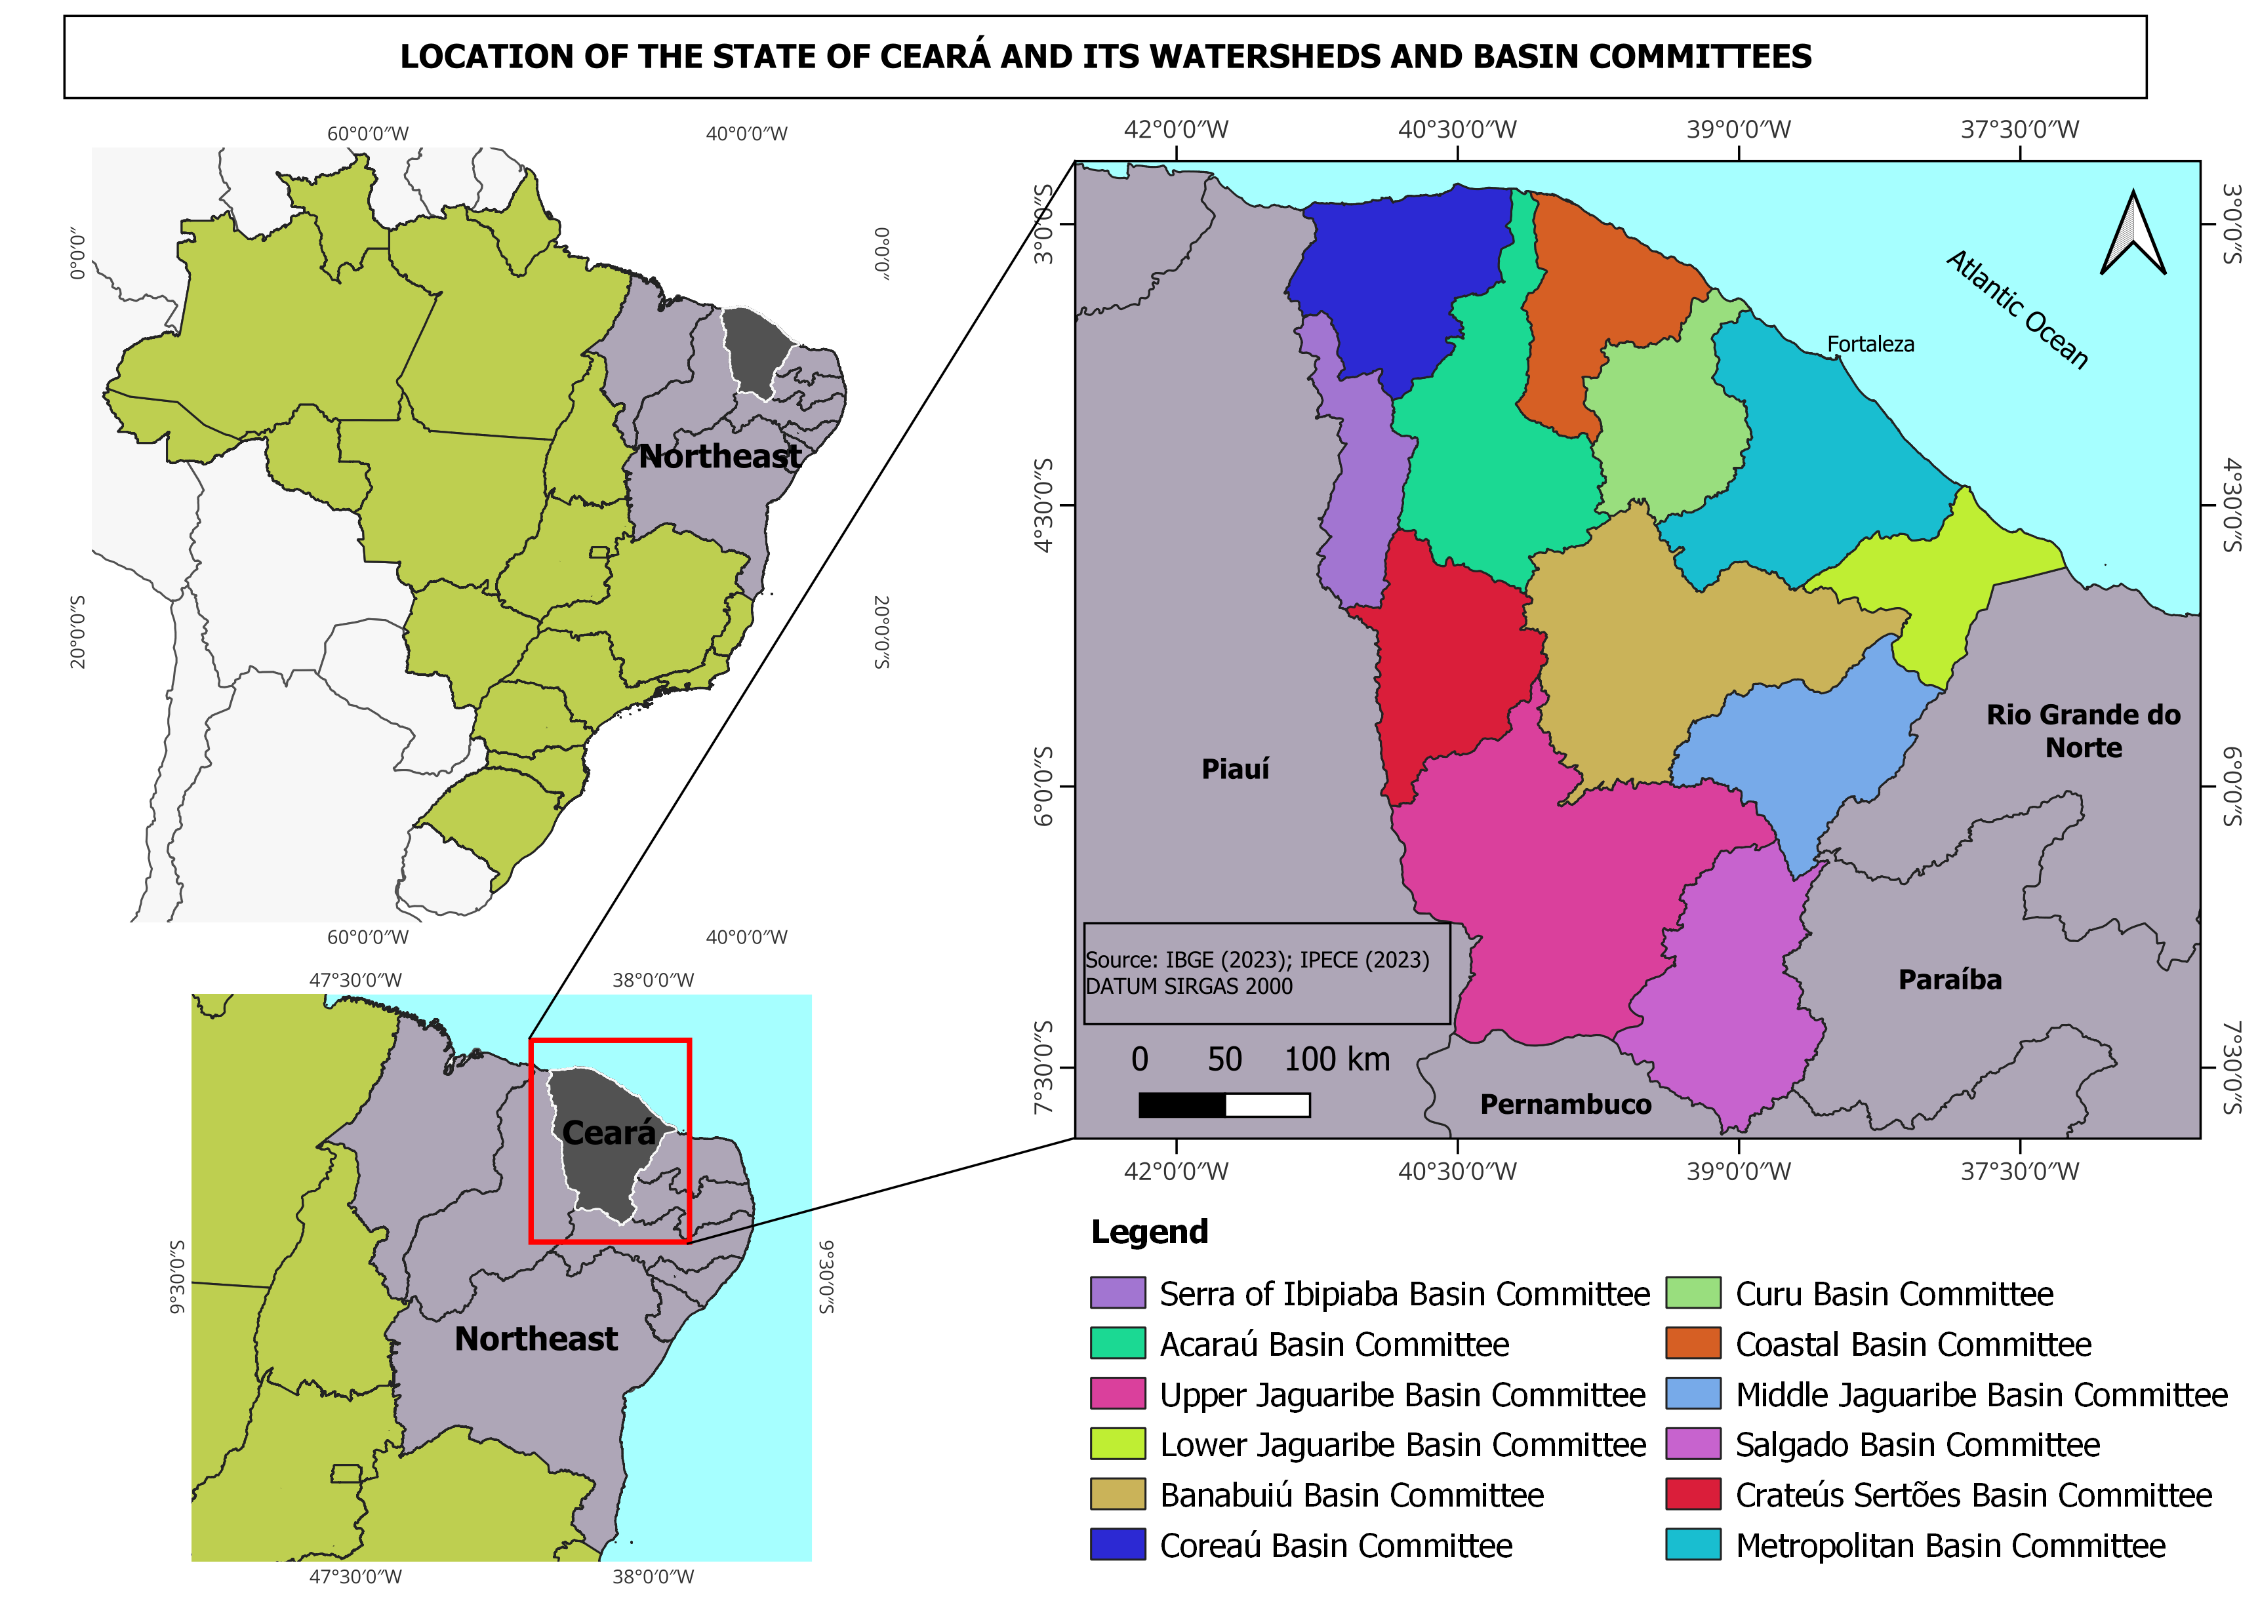 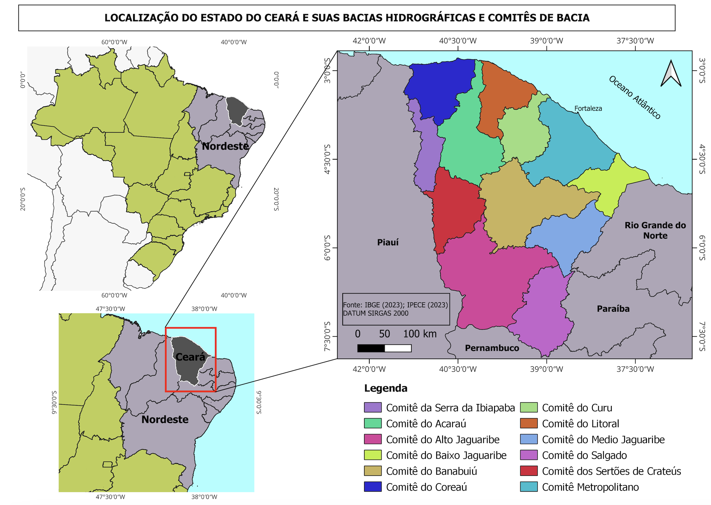

FIGURE 2 – Ceará Water Resource Management Committees.

SOURCE: Authors, authors, based on COGERH, 2023.

This state leadership continued to take place under the rhetoric of progress, emphasizing the need for modern, scientific, and democratic procedures, and for doing away with clientelistic traditions (Tendler, 1997; Taddei, 2011). In this context, traditional practices and knowledge are considered “unsuitable” for a “serious” political decision-making. This amounts to a model of participation mitigated by the exclusionary implications of an essentially technocratic, modernizing paradigm (Taddei, 2011).

## ***4.3 Patchy local governability***

In contrast to water management at the basin level, the local level is marked by a proliferation of water uses that are much less known and regulated by the state. In recent decades, the construction of reservoirs has multiplied in the Central Sertão of Ceará, as a strategy against longer droughts. According to a COGERH agent, in November 2021, there were an estimated 105 thousand artificial ponds throughout the state of Ceará (Burte *et al*, 2020).

There is a shared perception between COGERH, FUNCEME, and the WRMCs that this multiplicity of storage structures intercepts water that should reach rivers and/or strategic reservoirs. An interviewee from the Agrarian Development Secretariat (SDA) noticed the difficulty, in recent years, of finding reservoirs at their maximum water recharge, due to the multiplicity of existing dams. Furthermore, according to the interviewee, these dams were, for the most part, constructions lacking adequate design, subject to safety problems and even failures that could lead to a cascade effect. The shared perception is that this situation is due to the lack of capillarity, on the part of state organizations that oversee water management, in supervising the construction of these infrastructures – that are often used without corresponding water licenses. There is a tension between the social role of the aforementioned infrastructures, on the one hand, and, on the other, the safety of the dams as well as the overall water security. It was reported that the current effort of State organizations was precisely to identify and register these infrastructures.

The vast majority of these small reservoirs are built on private properties, without any collective forms of management and organization. Some larger ones are owned by communities or municipalities, especially when human consumption is among their multiple uses. Overall, they display amples diversities (and gaps) in management models, partly related to the variety of infrastructures to be managed. This is because, with each water crisis, a public intervention, whether state, federal, or municipal, tends to insert some new infrastructure for storage or water access. Therefore, it is common to find one community managing reservoirs, deep wells, desalination plants, waterholes, and cisterns, while relying on water tankers during the dry season. The functioning of communities is also connected to the strength of local social ties, which also generates high degree of institutional heterogeneity. Communities often lack collective rules that apply beyond the period of water scarcity.

The state of Ceará has shown little capacity to engage with these local water networks, and offer the necessary support to improve management,. Symmetrically, the lack of resources discourages communities from engaging in participatory spaces at the basin level, which accentuates the distance between different scales. All the while, financial support from the federal state to social organizations was cut during the Bolsonaro government (2019-2022), with visible consequences on the ability of these organizations to participate. In contexts where participation is very loosely related to material benefits, relatively weak groups (in terms of human and financial resources) tend to limit their participation, because they anticipate the risk of spending significant time and energy for relatively modest gains (Pierson, 2015; Barone & Mayaux, 2019). For example, during a field visit in November 2021 to the Posto Agropecuário settlement (in the Banabuiú hydrographic region), it was reported that the participation of its members in allocation meetings was very rare. This was due to the perception that this would do little to enhance their access to water given the predominance of their neighbor, who was portrayed as a large agricultural and livestock producer with greater political and economic clout.

Figure 3 summarizes the main historical steps of the governability project in Ceará and its current, ambivalent, results.

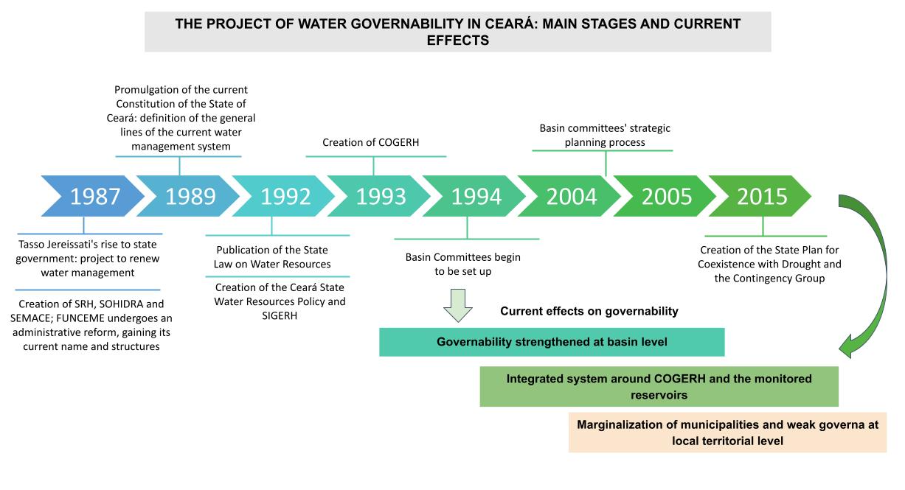  
FIGURE 3 – Key steps of Ceará’s water governability project .

SOURCE: Prepared by the authors, 2023.

This figure illustrates the key stages, since 1987, of the long-term project of strengthening governability for water resources in the state of Ceará. It shows its ambivalent effects today, depending on the scale considered. We now turn to an explanation of these ambivalent effects.

# ***5. The monopolization of attention by basin-level governance***

As the literature on policy agenda suggests, the attention of policy-makers is a scarce resource (Kingdon, 2003; Baumgartner & Jones, 2015). Its allocation, therefore, determines the content and hierarchy of the agenda, as well as the boundary between the problems that will be addressed by government authorities, and those that will not. Thus, agenda setting is the process by which an organization comes to pay attention to some issues rather than others (Jones & Baumgartner, 2005). Although the allocation of attention has been widely analyzed, it has rarely been considered as an effect of the governance architecture itself. This is precisely the causal relation that we highlight here.

## ***5.1 State-Committee relations, a central object of concerns and controversies***

The last three decades have been marked by recurring tensions between the state of Ceará and the WRMCs regarding authority over the planning, development, and allocation of water resources. In general, senior state officials consider that the state should retain strong control over management decisions, while members of the WRMCs tend to regret that the state remains too centralizing, contrary to what they consider to be the spirit of the Federal water law (n° 9,433) of 1997.

These controversies are not exclusive to Ceará, and can be observed throughout the country. This is not very surprising, as the introduction of any new decision-making space, such as WRMCs, leads to a reconfiguration of power and legitimacy. It is, therefore, unsurprising that the specifics of this reconfiguration have focused the attention of many staleholders. Across the country as a whole, two elements of frustration are frequently expressed by the Committees: the concentration of many relevant information by the state; and the fact that the Committees' decisions are not binding and, therefore, are routinely disregarded by the state (Trindade & Scheibe, 2019). Many Committees express the fear that this could contribute to an erosion of their legitimacy, which would result in users seeking favorable decisions directly from State governments (Trindade & Scheibe, 2019). In the specific case of Ceará, four issues, in particular, have focused attention and generated heated debates: the power to decide on water transfers between basins; the decision-making power over large hydraulic infrastructure projects; the role of COGERH in the functioning of the Committees; and the issue of water license.

Regarding the first theme, Ceará's water policy has been plagued by a paradox: at the very same time as basin management was being established, the issue of water transfers *between* basins was placed firmly on the State agenda. In this respect, a turning point was the near “collapse” of the Fortaleza metropolitan region (FMR) in 1993, eventually avoided with the construction of the *Canal do Trabalhador* (“worker channel”).

The transfers generated strong tensions between the state and the Committees. In addition to the governor and his cabinet, the central actor in this issue, on the state side, has been the State Water Resources Council (CONERH). Within it, power leans heavily towards state bureaucracies, which have representatives from 13 institutions (including the SWR as its Executive Secretary) out of a total of 24. The WRMCs began being represented in the CONERH only as of 2010, and with only a single seat, even though they represent different hydrographic regions, with different issues. CONERH arbitrates, in the last administrative instance, conflicts over water uses between basins. Therefore, it was him, under the ultimate authority of the Governor, who made the key decisions regarding the construction proposals for canals and pipelines to redistribute water from regions with higher availability to those with lower water availability (Vianna; Amaral Filho; Lócio, 2006).

The resulting tensions were particularly acute with regard to the construction of the Castanhão reservoir, which began in 1999, and changed the dynamics of the Jaguaribe valley to supply water to the Fortaleza metropolitan region. The demand for water in the FMR and the Pecém Industrial and Port Complex (CIPP) led to the construction of the “Integration Channel” (also known as *Eixão das Águas*) in 2004. The channel connects Castanhão with the Curral Velho reservoir, located in the municipality of Morada Nova, a work carried out through an agreement with the National Water Agency (ANA) (Ceará, 2018). During the unprecedented drought that struck the region between 2012 and 2018, the scarcity of water resources exacerbated conflicts over the Castanhão reservoir. The priority was given to transferring water to the FMR, at the expense of providing water resources for existing public irrigated areas. In 2015, the Middle Jaguaribe Committee voted not to transfer water to the Fortaleza metropolitan region, but this decision was later annulled by the CONERH. According to Cortez, Lima and Sakamoto (2017), in water allocation meetings, verbal confrontations and heated discussions intensified mainly by those who believed they had economic losses resulting from the capital's supply priority. It is likely that these tensions will continue in the future, since transpositions continue being a part of government priorities, as the State Government report, “Ceará 2050”, reiterates (Ceará, 2018).

Secondly, the State also pursues projects that tend to influence the uses of large reservoirs, which can generate tensions between the State and the Committees. A good example of this is the Malha d'Água project, which seeks to prioritize human consumption by implementing Water Treatment Stations (WTS) next to reservoirs with greater water guarantees, for subsequent supply to urban centers. The project was defined with great precision by the State, including the choice of locations for the implementation of the WTSs and the routes of the pipelines. Only after that was it presented to the Committees. Thus, the WRMC's position in the system is anything but guaranteed, which explains why its consolidation and institutional strengthening is the focus of so much debates.

Thirdly, the charging for water use represents the main source of funding for three of the twelve Committees only, given that the rest declare financial transfers from the state government to be the main source of their budget. It should be noted, however, that the perception of Committee members regarding COGERH is ambivalent: while they demand a greater role in defining the fee's value and its allocation back to their original basin, they also appreciate COGERH's contribution to the facilitation of Committee activities and negotiated allocation.

Finally, the articulation within the basins of planning with water rights is also under discussion. The Committees plan water uses, but do not issue the authorizations that correspond to them (Cortez *et al*., 2017). According to the legal framework, basin plans must comply with water licenses granted by SWR (whose criteria are established by CONERH) but there is no formal mechanism to link these two procedures. This point is problematic because, in addition to mismatch between the two, there is a lack of updated information on actual consumption by type of crop and river basin. In an interview in December 2021, an SDA representative highlighted the lack of integration between the Committees’ activities and the delivery of water licenses to farmers.

Debates about the relationship between the Committees and the state, which have roiled Ceará's water policy for over three decades, have thus attracted a lot of attention. Although it is a perfectly understandable phenomenon, it has had the unintended effect of saturating actors' attention and keeping the issue of local governability largely off the agenda.

## ***5.2 A lack of attention to local governability***

The issue of local governance, in general, is barely visible in the various state policy documents. For instance, State Law No. 14,844, dated December 28, 2010, which establishes the State Policy for Water Resources, outlines the prerogatives of CONERH, COGERH, and the Committees, but says nothing of the associations and communities actively involved in the management of small reservoirs. As a result, they are excluded from the system of integrated water resources management (SIGERH, see Article 40). Subsection II of Section IV, which establishes the various prerogatives of COGERH, does not address the issue ofcoordination between the level of large strategic reservoirs and that of unmonitored dams.

In terms of governability, the Strategic Water Resources Plan, which was developed following a meticulous and remarkably inclusive participatory process (referred to as the “Water Pact”), did not include the issue of implementation in its list of challenges. Although it emphasized the need to strengthen “[...] social participation channels in terms of training, improving representation, and representativeness” (Ceará, 2009, p. 25), it did not mention the challenge of establishing effective control over the 105,000 unmonitored water reservoirs. Furthermore, when discussing the limitations of the water monitoring network developed by COGERH, it mainly mentioned the lack of consolidated data on water quality, not the fact that this network only covered a small minority of the State’s rivers in the first place.

More recently, this invisibilization has been reflected in the prospective document “CEARÁ 2050: Special Sectoral Study on Water Resources” published in 2018. The report, rich in content, does not mention the proliferation of smaller reservoirs among the main challenges and weaknesses of the system (Ceará, 2018). These reservoirs are discussed separately from the strategic reservoirs, as if there were no interdependence between the two. The only mention of a relationship between the monitored system and the unmonitored systems expresses a very optimistic view of complementarity: “Small reservoirs can reduce seasonal variability and large reservoirs can reduce the average severity of extreme drought or flood events” (p. 18). This optimism erases the challenges that the latter pose to the former. Nor does it mention the need to mitigate disparities in material and informational terms, to make participation spaces more attuned to actors’ actual capabilities.

Lastly, the lack of attention to local governability is also evident in the limited focus given, within the watershed plans, to agrarian development policies, even though they have the most territorial reach. The State’s Agrarian Development system produces policies aimed at a public that has not benefited from large infrastructures, such as large reservoirs or perennial valleys. This is precisely the population that depends on small reservoirs and the indiscriminate drilling of wells. According to an SDA agent, when considering the management of the state's water resources, it would be essential to think about the Cistern Policy, for example, a policy administered by the SDA that can impact withdrawals from reservoirs as well as the retention of people in rural areas more generally.

# ***6. A governability project without municipalities?***

Despite some stated intentions, municipalities have remained in a marginalized position in the state water resources management system. This is a problem for governability, because municipalities constitute the *locus* par excellence for local democratic legitimacy, in addition of holding some formal prerogatives with regard to water resources.

## ***6.1 A weak role with harmful consequences for local governability***

Municipalities have many prerogatives related to basic sanitation, rainwater, and the use, occupation, and conservation policies for soil and the environment (Aith & Rothbarth, 2015). However, the 150 municipalities of Ceará that are in the semi-arid region (81.5% of its 184 municipalities) currently play a relatively minor role in the governance of water resources.

The proportion of seats granted by law to municipalities within the scope of WRMCs is comparable to that granted to the State and the Federal Government. This results in a distribution of 30% of seats for water users; 30% for civil society; 20% for municipalities; and 20% for State and Federal Public Authorities (SWR, 2022). However, given the fact that municipalities, due to their geographic, economic, and demographic particularities, should inherently have diverse positions about water resources, they face limitations in their ability to express the diversity of their preferences within such a system (in a country like France, for example, the proportion is 40%). As an illustration, Table 1 provides the allocation of seats designated for municipalities in each of the twelve CBHs in the state, along with the number of municipalities within their respective watersheds.

TABLE 1: Water Resource Management Committees in Ceará and representatives of municipalities.

|  |  |  |  |  |  |
| --- | --- | --- | --- | --- | --- |
| **No.** | **WRMC** | **Year of Creation** | **Total seats at WRMC** | **Total municipalities comprising the basin** | **Number of seats for Municipalities (20%)** |
| 1 | Curu | 1997 | 50 | 15 | 10 |
| 2 | Baixo Jaguaribe | 1999 | 50 | 09 | 10 |
| 3 | Médio Jaguaribe | 1999 | 40 | 13 | 8 |
| 4 | Alto Jaguaribe | 2002 | 50 | 24 | 10 |
| 5 | Banabuiú | 2002 | 48 | 15 | 9 |
| 6 | Salgado | 2002 | 50 | 23 | 10 |
| 7 | Metropolitan | 2003 | 60 | 31 | 12 |
| 8 | Acaraú | 2004 | 40 | 28 | 8 |
| 9 | Litoral | 2006 | 40 | 13 | 8 |
| 10 | Coreaú | 2006 | 30 | 24 | 6 |
| 11 | Serra da Ibiapaba | 2013 | 30 | 10 | 6 |
| 12 | Sertões de Crateús | 2013 | 30 | 9 | 6 |

SOURCE: COGERH, 2023.

Perhaps as a result of this diminished role, it is observed that highly experienced professionals in the field are increasingly distancing themselves from positions within municipalities, prioritizing their involvement in the Committees and Commissions (Taddei, 2009).

Likewise, Chapter IX of State Law No. 14,844 of 2010 on State Water Resources Policy, entitled “On the participation of municipalities”, has two articles. The first (art. 54) stipulates that the State should sign “cooperation and technical and economic-financial assistance agreements” with municipalities over water resources, but without specifying the procedures for establishing such agreements, which have not been implemented to date. The second article (art. 55) simply says that the state should “coordinate with the Federal Government, other States, and Municipalities” in order to manage water resources.

This observation of a peripheral role is present among agents of the state itself. One interviewee from the SDA characterizes the relationship between the state government and municipalities as hierarchical, resembling a tutor and ward logic. It is noted that the demands that come to the Secretariat from municipalities largely concern resources, such as equipment, for example, without envisioning a more systematic collaboration and coordination.

This situation is not exclusive to Ceará. More than fifteen years after the nationwide mandate (Law No. 9,433 of January 8, 1997) for the decentralization of water resources management, the participation of local governments is still sktechy in much of the country. In their literature review regarding the main limitations to the proper functioning of Basin Committees in Brazil, Trindade and Scheibe (2019) the low participation from the municipal level of government.

***6.2 The municipality as an indispensable actor in local water management***

The municipal scale is relatively more accessible to control and social demands (Holanda, 2016). Within the Brazilian federal system, this sphere of government also has regulatory, fiscal, and monitoring powers over local environmental management, thus being able to grant or limit the right to certain uses, according to its interests. Therefore, low participation by municipal governments tends to considerably harm the integrated management of water resources (Trindade & Scheibe, 2019). The participation of municipal administrations should be a central concern.

According to an interviewee from the SDA, it is inconceivable, for example, that municipalities should possess a multitude of reservoirs within their territories without any of them being monitored by the state (via COGERH). This highlights the necessity to discuss the role, power, and municipal management structure of these reservoirs.

However, this situation has not remain hitherto unquestioned. Some formal steps have been taken and continue to be taken in order to give municipalities a more prominent role, but their implementation remains limited or is still in its early stages. It is worth mentioning the Municipal Plans for Drought Preparedness and Resilience, a pilot experiment initiated in 2015 under the State Council for Rural Development - CEDR. Its objective is to contribute to reducing the vulnerability of family farmers to drought events, whether in “good” or “bad” years. It encompasses proactive and preventive actions, aiming to respect and strengthen local vocations (SWR, 2022.). Its elaboration involved all relevant municipal agents.

However, regarding the management of water and sewage services, which fall under municipal jurisdiction, it should be noted that in July 2021, microregions for water and sewage were created. According to an interview with a representative from the Department of Cities, this adds another actor to the management of water and sewage services in Ceará. In addition to the state government, which manages raw water; the Ceará Water and Sewage Company (CAGECE), the operator of water and sewage services; and the municipalities, which were the previous owners of these services, there are now microregional authorities which have become co-managers of water and sewage services. This is an instance that is neither state nor municipal, and that does not have a proper administrative structure or budget. According to the interviewee, however, this calls into question the municipalities’ ownership of the aforementioned services in their territories. However, the same interviewee also highlighted that this innovation may end up promoting a modicum of inter-scalar cooperation as, from now on, decisions regarding water services will be deliberated upon in microregions’ collegial boards. Thus, the water system in the state continues to evolve, and it is too early to assess the effects of this reform on the role of municipalities regarding water.

# ***7. Conclusion: rethinking local governance to improve water governability***

After four decades of reforms in the water resources sector, there is little doubt that the water governance system of Ceará has strengthened the governability of river basins. At this level, the state knows its water resources – their variability and their uses – better than before, and is able to mobilize civil society actors to plan for their uses. While the Committees have introduced participation as a key element of water management, they have also become an effective instrument to consolidate the coordination power of the state, especially through the central position of COGERH and the arbitration power of CONERH.

At the same time, however, the governance system has not prevented a deterioration in local governability, at the level of municipalities and rural communities. This is because it focused the attention of actors mostly on the (challenging) implementation of basin governance and kept municipalities in a subordinate role, as part of a modernizing strategy to combat “old local politics.” This disregard for local governability is now jeopardizing the operation of the large water system itself: an increase in unmonitored reservoirs, very weak control over water use, and a lack of territorial coherence in water-related policies (sanitation, agriculture, land use, etc.) threaten the sustainability of large reservoirs.

These two effects generate negative feedbacks: they are currently raising questions about the limitations of the governance system and call for their reform and evolution. This observation has theoretical consequences: it points to the inclusion of two new mechanisms (the monopolization of attention and the marginalization of an influential actor) into the list of negative feedbacks (Weaver, 2010; Béland, 2019). But it also leads to more practical recommendations.

After the non-municipal phase of the hydraulic solution, there is a need, in this new historical sequence, to rely more on municipalities to prevent water from becoming (increasingly) ungovernable due to a governance that remains too centralized. Governability depends not only on the inherent capabilities of the governance system (i.e., the various resources it can mobilize) but also on the acceptance of the target population to be governed (Kooiman, 2008). Therefore, it is necessary to build a more inclusive local governance systems that integrate the state, municipalities, and users while generating legitimacy.

This brings to light considerations about the capacity of State bureaucracies to take part in the governance of small reservoirs. This, in turn, requires a break with the dichotomous “investor state” approach that has long prevailed in state interventions. This type of State invests a lot in the design and construction of facilities, but has little concern with the subsequent (co)management of these facilities. Whatever the exact forms of this future co-management, social organizations should have the necessary resources and capabilities to effectively participate in deliberations and decisions. A more democratic and imaginative form of local governance is therefore needed to open a new chapter in the "Cearense model".

***Acknowledgments***

We would like to thank the Sertões project - Sustainability and Water and Territorial Resilience in the Sertões of Northeast Brazil - and its funders, the Foundation for Meteorology and Water Resources of Ceará (FUNCEME), as well as the French Development Agency (AFD). The project made this collaboration possible by organizing the activities of the working group on water resources governance in the state of Ceará (group #3), financing field research, and hosting the collective field school. We also thank the French Center for International Cooperation in Agricultural Research for Development (CIRAD) who contributed to the scholarship of one of the authors.

## ***References***

Adam, C.; Hurka, S.; Knill, C.; Steinebach, Y. *Policy Accumulation and the Democratic Responsiveness Trap* (Cambridge Studies in Comparative Public Policy). Cambridge: Cambridge University Press, 2019. doi:10.1017/9781108646888

Aith, F.M.A.; Rothbarth, R. O estatuto jurídico das águas no Brasil. *Estudos Avançados*, *[S. l.]*, 29(84), 163-177, 2015. https://doi.org/10.1590/S0103-40142015000200011

Barone; S.; Mayaux, P. L. *Les politiques de l'eau*. Issy-les-Moulineaux Cedex: LGDJ, 2019. ISBN 978-2-275-06003-3

Baumgartner, F.R.; Jones, B.D. *The politics of information***:** problem definition and the course of public policy in America. Chicago: University of Chicago Press, 2015.

Béland, D.; Schlager, E. Varieties of Policy Feedback Research: Looking Backward, Moving Forward. *Policy Stud J*, 47, 184-205, 2019. <https://doi.org/10.1111/psj.12340>

Brazil. *Lei nº 9.433, de 8 de janeiro de 1997*. Institui a Política Nacional de Recursos Hídricos, cria o Sistema Nacional de Gerenciamento de Recursos Hídricos, regulamenta o inciso XIX do art. 21 da Constituição Federal, e altera o art. 1º da Lei nº 8.001, de 13 de março de 1990, que modificou a Lei nº 7.990, de 28 de dezembro de 1989. Brasília: DOU de 09/01/1997.

Burte, J.D.P.; Martins, E.S.; Augusseau, X. Garjulli, R. *Projeto Premissa*. Resiliência e desenvolvimento sustentável rural na região Banabuiú/Médio Jaguaribe. Diagnóstico Territorial e dos Sistemas de Governança e de Informação. Fortaleza: FUNCEME-CIRAD, 2020.

Busemeyer, M.; Abrassart, A.; Nezi, R. Beyond Positive and Negative: New Perspectives on Feedback Effects in Public Opinion on the Welfare State. *British Journal of Political Science,* 51(1), 137-162, 2021. doi:10.1017/S0007123418000534

Cárdenas, M. State Capacity in Latin America. *Economía*, *10*(2), 1–45, 2010. <http://www.jstor.org/stable/25800045>

Ceará. *Lei nº 11.996 de 24 de julho de 1992*. Dispõe sobre a Política Estadual de Recursos Hídricos, institui o Sistema Integrado de Gestão de Recursos Hídricos - SIGERH e dá outras providências. Fortaleza: DOE de 29/07/1992.

Ceará. Assembleia Legislativa. *Plano estratégico dos recursos hídricos do Ceará*/ Conselho de Altos Estudos e Assuntos Estratégicos, Assembleia Legislativa do estado do Ceará; Eudoro Walter de Santana (Coordenador) - Fortaleza: INESP, 2009. Disponível em: [https://portal.cogerh.com.br/wp-content/uploads/2018/09/Plano-Estrat%C3%A9gico-dos-Recursos-H%C3%ADdricos-do-Cear%C3%A1.pdf](https://portal.cogerh.com.br/wp-content/uploads/2018/09/Plano-Estratégico-dos-Recursos-Hídricos-do-Ceará.pdf)

Ceará. *Lei nº 14.844 de 28 de dezembro de 2010*. Dispõe sobre a Política Estadual de Recursos Hídricos, institui o Sistema Integrado de Gestão de Recursos Hídricos - SIGERH, e dá outras providências. Fortaleza: DOE de 30/12/2010.

Ceará. Ceará 2050. *Estudo Setorial Especial Recursos Hídricos*; Francisco de Assis Souza Filho - Fortaleza: 2018. Available in: <https://www.ceara2050.ce.gov.br/api/wp-content/uploads/2018/10/ceara-2050-estudo-setorial-especial-recursos-hidricos.pdf>

COGERH – Companhia de Gestão dos Recursos Hídricos. *Comitês de Bacias Hidrográficas*. 2023. Disponível em: https://portal.cogerh.com.br/banabuiu-2/

Chacon, S.S. *O sertanejo e o caminho das águas*: políticas públicas, modernidade e sustentabilidade no semiárido. Fortaleza: Banco do Nordeste do Brasil, 2007. (Série BNB teses e dissertações, n. 08).

Cortez, H.S.; Lima, G.P.; Sakamoto, M.S. A seca 2010-2016 e as medidas do estado do Ceará para mitigar seus efeitos. *Parcerias Estratégicas*, 22(44), 83-118, 2017. Disponível em: <https://seer.cgee.org.br/parcerias_estrategicas/article/view/858>

Frota, P.V.; Da Silva, U.P.; Sales, C.J.; Souza Filho, F. A. Comissões gestoras de sistemas hídricos no estado do Ceará. XX Simpósio Brasileiro de Recursos Hídricos, Bento Gonçalves, 17-22 de novembro de 2013.

Gutiérrez, R. Participatory Water Policy in Ceará, Brazil: Approaches and Political Viability. *In:* *XI Congreso Internacional Del CLAD/Centro Latinoamericano de Administración para el Desarrollo*. Ciudad de Guatemala, 7 y 10 de noviembre de 2006.

Hacker, J.S.; Pierson, P. Policy Feedback in an Age of Polarization. *The Annals of the American Academy of Political and Social Science*, 685(1), 8–28, 2019.

<https://doi.org/10.1177/0002716219871222>

Holanda, A.C.P. A Importância do Município na Estrutura Federalista Brasileira para a Concretização de uma Democracia Participativa. *Revista Controle – Doutrina e Artigos*, 14(2), 357-390, 2016. Disponível em: https://dialnet.unirioja.es/servlet/articulo?codigo=6167793

Huntington, S.P. *Political Order in Changing Societies*. New Haven/London, Yale University Press: 1968.

______. Chapter III - The United States. *In*: Crozier, M.; Huntington, S.P.; Watanuki, J. *The Crisis of Democracy, Report on the Governability of Democracies to the Trilateral Commission*. New York: New York University Press, 1975. p.59-128

Jacobs, A.M.; Weaver, R.K. Self-Undermining Feedback. *Governance*, 28, 441-457, 2015. <https://doi.org/10.1111/gove.12101>

Jones, B.D.; Baumgartner, F.R. *The politics of attention:* how government prioritizes problems*.* [s.l.] University of Chicago Press, 2005.

Kingdon, J.W. *Agendas, alternatives, and public policies*. 3. ed. New York: Harper Collins, 2003.

Kooiman, J. Exploring the concept of governability. *Journal of Comparative Policy Analysis*, 10, 171–190, 2008. https://doi. org/10.1080/13876980802028107

Kooiman, J.; Bavinck, M.; Chuenpagdee, R., Mahon, R.; Pullin, R. Interactive governance and governability: an introduction. *Journal of Transdisciplinary Environmental Studies*, 7(1), 1-11, 2008. Disponível em: https://journal-tes.ruc.dk/wp-content/uploads/2021/05/no_1_Intro-1.pdf

Lepont, U. Public spending and austerity: The two faces of the French Investor State, *Competition & Change*, 2023, [OnlineFirst](https://journals.sagepub.com/toc/ccha/0/0), <https://doi.org/10.1177/10245294231213683>

Lemos, M.C; Oliveira, J.L.F. Water Reform across the State/Society Divide: The Case of Ceará, Brazil, *International Journal of Water Resources Development*, 21(1), 133-147, 2005. DOI: [10.1080/0790062042000316857](https://doi.org/10.1080/0790062042000316857)

Mayntz, R. Governing Failures and the Problem of Governability: Some Comments on a Theoretical Paradigm. *In*: Kooiman, J. (Ed.), *Modern Governance:* New Government-Society Interactions. London: Sage, 1993. p. 9-20.

Medeiros, E.L., Oliveira, C.T., Henry-Silva, G.G. Avaliação da sustentabilidade ambiental, social e econômica de uma bacia hidrográfica do semiárido brasileiro, *Desenvolvimento e Meio Ambiente*, Vol. 61, p. 1-17, jan./jun. 2023. DOI: 10.5380/dma.v61i0.78914 e-ISSN 2176-9109.

Mettler, S.; Sorelle, M. Policy feedback theory. *In*: Weible, C. M; Sabatier, P. A. *Theories of the policy process*. New York: Routledge, 2018, p. 103-134.

Pereira Júnior, A.A. Legitimidade e governabilidade na regulação do sistema financeiro. *Revista Direito GV*, 4(2), 517–538, 2008. <https://doi.org/10.1590/S1808-24322008000200008>

Pierson, P. When Effect Becomes Cause: Policy Feedback and Political Change. *World Politics*, 45(4), 1993, p. 283-310. <https://doi.org/10.2307/2950710>.

Pierson, P. *Politics in Time: History, Institutions, and Social Analysis*, Princeton, N.J.: Princeton University Press, 2004.

Pierson, P. Power and path dependence. In J. Mahoney & K. Thelen (Eds.), *Advances in Comparative-Historical Analysis*, pp. 123-146. Cambridge: Cambridge University Press, 2015. doi:10.1017/CBO9781316273104.006

Rocha, C.M.S.; Gomes, D.D.M.; Rocha, L.P.F.O.; Cavalcante, I.N. Considerações sobre a Legislação dos Recursos Hídricos do Ceará. *In*: Medeiros, C.N.; Gomes, D.D.SM.; Albuquerque, E.L.S.; Cruz, M.L.B. *Os Recursos Hídricos do Ceará:*Integração, Gestão e Potencialidades. Fortaleza: IPECE, 2011. Seção II – Gestão dos Recursos Hídricos. p.136-163. Disponível em: <https://www.ipece.ce.gov.br/wp-content/uploads/sites/45/2015/02/Recursos_Hidricos_do_Ceara.pdf>

Schmid, N.; Sewerin, S.; Schmidt, T.S. Explaining Advocacy Coalition Change with Policy Feedback. *Policy Stud J*, 48, 1109-1134, 2020. <https://doi.org/10.1111/psj.12365>

SOHIDRA – Superintendência de Obras Hidráulicas.*Institucional. Sobre.* s.d. Disponível em: <https://www.sohidra.ce.gov.br/institucional/>

Song, A.M.; Johnsen, J.P.; Morrison, T.H. Reconstructing governability: How fisheries are made governable. *Fish and Fisheries* 19, 377-389, 2018. DOI: 10.1111/faf.12262.

SRH – Secretaria dos Recursos Hídricos. *Apresentação.* 2022. Available in: <https://www.srh.ce.gov.br/apresentacao/>

Taddei, R. Watered-down democratization: modernization versus social participation in water management in Northeast Brazil. *Agric Hum Values* 28, 109–121, 2011. <https://doi.org/10.1007/s10460-010-9259-9>.

Taddei, R.; Gamboggi, A.L. Etnografia, meio ambiente e comunicação ambiental. *Revista Caderno Pedagógico*, 8(2), 2011. Disponível em: https://ojs.studiespublicacoes.com.br/ojs/index.php/cadped/article/view/1174/1041.

Tendler, J. *Good government in the tropics*. Johns Hopkins University Press, 1998.

Trindade, L.D.L.; Scheibe, L.F. Water Management: Constraints to and contributions of Brazilian watershed management committees. *Ambiente & Sociedade*, *22*, e02672, 2019. <https://doi.org/10.1590/1809-4422asoc20160267r2vu2019L2AO>.

Vianna, P.J.R.; Amaral Filho, J.; Lócio, A.B. *Os Recursos Hídricos do Ceará:* Integração, Gestão e Potencialidades. Texto para discussão nº 22. Governo do estado do Ceará – Instituto de Pesquisa e Estratégia Econômica do Ceará-IPECE, 2006. Disponível em: <https://www.ipece.ce.gov.br/wp-content/uploads/sites/45/2014/02/TD_22.pdf>

Weaver, K. Paths and Forks or Chutes and Ladders? Negative Feedbacks and Policy Regime Change. *Journal of Public Policy,* 30(2), 137-162, 2010. doi:10.1017/S0143814X10000061.

1. To which users commissions may also be added. These are set up for particular reservoirs that do not yet have a management committee approved by the WRMC. While management commissions are valid for 4 years, users commissions are operational only for one specific process of negotiated allocation.