ANALYSIS OF THE PSYCHIATRIC HOSPITALIZATIONS THROUGH THE SUS IN PIAUÍ, BRAZIL, FROM 2008 TO 2020

ABSTRACT
Objective: to analyze the behavior of data referring to psychiatric hospitalizations in Piauí between 2008 and 2020.
Method: an ecological study conducted with secondary data referring to psychiatric hospitalizations between 2008 and 2020 in Piauí, obtained from the Hospital Information System/DATASUS. Descriptive and linear regression analyses were performed.
Results: a total of 40,608 psychiatric hospitalizations were found. The main causes were schizophrenia (17,877) and mood disorders (8,239). Mental retardation and schizophrenia presented higher costs and mean hospitalization times. A reduction in the number of hospitalization was recorded from 2009 to 2012 and there was increase between 2016 and 2019, regardless of age and gender. Hospitalizations were more frequent among adults (94.4%) and men (62.4%).
Conclusion: the reduction in the number of psychiatric hospitalizations in Piauí from 2009 to 2012 coincides with the closing of the state's psychiatric hospital and with the strengthening of the Psychosocial Care Network. The data reflect previous mental health policies and allow planning health strategies.
DESCRIPTORS: Mental Health Care; Mental Disorders; Time Series Studies; Hospitalization; Health Information Systems.

INTRODUCTION
The beginning of the Brazilian Psychiatric Reform process took place in a context of struggle to change the care and management models in health practices, for the defense of collective health, equality in the provision of services and protagonism of workers and users of health services, in the processes of management and production of care technologies. These ideals were mirrored in the Italian model, which mainly advocated deinstitutionalization of users, with a view to overcoming asylum violence and, with this, rescuing citizenship through reintegration into social life, breaking with the current hospital model¹⁻².
Changes in the mental health field are related to strategic regulations, such as the Declaration of Caracas published in 1990, which guides reforms in mental health care in the Americas, as well as to Federal Law No. 10,216/2001, which provides for the protection and rights of people with mental disorders and redirects the mental health care model in Brazil. Ordinance No. 3,088/2011 established the Psychosocial Care Network (Rede de Atenção Psicossocial, RAPS) for people with mental distress or disorders and needs arising from the use of crack, alcohol and other drugs, within the scope of the Unified Health System (Sistema Único de Saúde, SUS). It integrates a territorialized network, which covers assistance-related measures from primary to hospital care, in line with Law No. 10,216/2001, encompassing the promotion of contractuality of its users, thus valuing the social reintegration carried out by the multiprofessional team³.
There are several devices for health care and social rights within the RAPS, namely: primary care as gateway, psychosocial care with specialties, Psychosocial Care Centers (Centros de Atenção Psicossocial, CAPS) in their most varied subtypes, according to the need for health care to be provided to the users and, finally, hospital care to support crisis situations³⁻⁴. We reiterate the urgent need to include people with mental disorders in the health care network (Basic Health Units - BHUs, Family Health Strategy - FHS, CAPS and other services), to ensure adequate treatment⁵.
Mental health care must be essentially community-based, but hospitals play a backup role. That is, mental health services are offered in the usual community contexts close to the population served, with hospital admissions available as a last resort, only when necessary and respecting brevity⁶⁻⁷. It is only when out-of-hospital resources are exhausted and the legal requirements for hospitalization are met that health managers must act in order to guarantee the hospitalization of all those who need it⁵.
Although scarce, in Brazil the studies that analyze data referring to psychiatric hospitalizations address states from the Southeast and South regions. Thus, it is important to investigate and characterize how these admissions to the psychiatric hospital component and/or general hospitals have been taking place in terms of beds for psychiatric care. The relevance of the study consists in knowing the current state of the RAPS in Piauí, particularly the hospital component, through an analysis of the data referring to psychiatric hospitalizations. The objective of this study was to analyze the behavior of data referring to psychiatric hospitalizations in Piauí between 2008 and 2020.

METHOD
An ecological, retrospective and time-based study of health data. Data collection was carried out in May 2021, considering all hospitalizations with the aforementioned object, recorded on the virtual website of the SUS Informatics Department (DATASUS).
The health information was accessed through TABNET, choosing the option referring to the epidemiological and morbidity data. Among the group of options referring to the SUS information systems, hospital morbidity data were surveyed, made available through the Hospital Information System (Sistema de Informações Hospitalares, SIH/SUS) and based on general hospital morbidity by place of residence (choosing Piauí as geographic area). This option provides more recent data, from 2008 onwards, which was the reason to choose the historical series comprised by 13 full years.
The content of the tables generated for this research, on the virtual site, corresponded to the hospitalizations; all available periods of years already finished were chosen, at the time the data were collected (from January 2008 to December 2020). In the set of available selections, it was chosen to work with chapter V of ICD-10 (mental and behavioral disorders) and the list of morbidities from ICD-10 as follows: dementia, mental and behavioral disorders due to alcohol use, mental disorders and behavioral disorders due to the use of other psychoactive substances, schizophrenia and schizotypal and delusional disorders, mood (affective) disorders, neurotic and stress-related and somatoform disorders, mental retardation, and other mental and behavioral disorders. These morbidities were grouped in order to turn them into the main study variable.
Other variables considered were as follows: municipalities of Piauí, mean hospitalization time, mean hospitalization cost, age group (from 10 to 19 years old, from 20 to 59 years old, and 60 years old or more) and gender. Table-based analyses were performed, with absolute data grouped in SPSS Statistics 24, with conduction of a descriptive and inferential analysis. Linear regression was employed in the analysis of the number of hospitalizations by year and by cause, with calculation of the coefficient of determination (R²).
This research was carried out with secondary epidemiological data in the public domain and available online, for analysis and assessment of the health of the population of a Federative Unit in the Brazilian Northeast region. Consequently, evaluation by a Research Ethics Committee is waived, as described in Resolution No. 510/2016 of the National Health Council.

RESULTS
A total of 40,608 hospitalizations related to mental/behavioral disorders were found. Of these, 12,285 (30.2%) correspond to those recorded in the municipality of Teresina, followed by 8,595 (21.1%) in Parnaíba and 1,401 (3.4%) in Picos.
Greater allocation of financial resources for hospitalization occurred in the cases of users from Picos and Teresina (R$ 1,380.45 and R$ 1,408.89 respectively), followed by Parnaíba (R$ 804.97). The same pattern occurs in relation to the mean hospitalization time: for Picos residents, it was 40.4 days; in the capital it was 28.0 days and, in Parnaíba, it was 25.6 days.
There was a marked reduction in the number of psychiatric hospitalizations in Piauí from 2009 to 2012. In the entire time series, the main reason for psychiatric hospitalizations was schizophrenia (17,877 cases), followed by 8,239 hospitalizations due to mood disorders (Table 1).

Table 1 - Number of hospitalizations due to mental/behavioral disorders by year of the time series. Piauí, PI, Brazil, 2008 - 2020
Mental/Behavioral disorders | 2008 | 2009 | 2010 | 2011 | 2012 | 2013 | 2014 | 2015 | 2016 | 2017 | 2018 | 2019 | 2020 | R² | p-value*
Dementia | 47 | 56 | 20 | 22 | 23 | 27 | 22 | 20 | 31 | 26 | 26 | 19 | 30 | 0.631 | 0.581
Mental and behavioral disorders due to alcohol consumption | 831 | 769 | 638 | 392 | 328 | 225 | 301 | 313 | 260 | 304 | 342 | 430 | 281 | 0.940 | 0.000
Mental and behavioral disorders due to consumption of other psychoactive substances | 419 | 465 | 487 | 499 | 330 | 292 | 427 | 398 | 417 | 505 | 530 | 497 | 448 | 0.029 | 0.209
Schizophrenia, schizotypal and delusional disorders | 2,596 | 2,435 | 1,642 | 1,423 | 1,293 | 1,228 | 1,214 | 937 | 912 | 1,021 | 1,007 | 1,047 | 847 | 0.962 | 0.000
Mood (affective) disorders | 828 | 854 | 733 | 651 | 599 | 693 | 631 | 510 | 427 | 560 | 647 | 560 | 472 | 0.809 | 0.000
Neurotic disorders related to stress and somatoform disorders | 28 | 36 | 34 | 35 | 25 | 12 | 21 | 12 | 24 | 44 | 49 | 55 | 46 | 0.006 | 0.284
Mental retardation | 149 | 105 | 76 | 49 | 45 | 38 | 31 | 28 | 20 | 25 | 33 | 34 | 30 | 0.925 | 0.000
Other mental and behavioral disorders | 129 | 205 | 154 | 85 | 99 | 77 | 82 | 85 | 129 | 145 | 162 | 172 | 142 | 0.201 | 0.170
Total | 5,027 | 4,925 | 3,784 | 3,156 | 2,742 | 2,592 | 2,729 | 2,303 | 2,220 | 2,630 | 2,796 | 2,814 | 2,296 | - | -
Source: The authors (2021). Data from the SUS Hospital Information System (SIH/SUS).
*It refers to Spearman's correlation coefficient
R²: Coefficient of determination

A strong relationship was found between the total frequency of psychiatric hospitalizations each year and the frequencies of hospitalizations due to alcohol use (rho=+0.929; p=0.000), schizophrenia (rho=+0.868; p=0.001), mood disorders (rho=+0.831; p=0.000) and mental retardation (rho=+0.885; p=0.000). In particular, 94.0%, 96.2%, 80.9% and 92.5% of the variability between the values observed regarding frequency of hospitalizations for these four disorders, respectively, are explained by the relationship between them and the total frequency of psychiatric hospitalizations in all the periods recorded.
Mental retardation (R$ 2,831.72) and schizophrenia (R$ 1,738.06) presented higher hospitalization costs. The same disorders were responsible for longer hospitalizations: 58.9 and 38.8 days, respectively (Table 2).

Table 2 - Number of hospitalizations, mean cost per hospitalization and hospitalization time related to mental/behavioral disorders. Piauí, PI, Brazil, 2008 - 2020
Mental/Behavioral disorders | Hospitalizations | Mean cost per hospitalization (in reais) | Mean hospitalization time (in days)
Dementia | 369 | 1,076.74 | 28.4
Mental and behavioral disorders due to alcohol consumption | 5,566 | 657.43 | 14.4
Mental and behavioral disorders due to consumption of other psychoactive substances | 5,781 | 886.89 | 15.3
Schizophrenia, schizotypal and delusional disorders | 17,877 | 1,738.06 | 38.8
Mood (affective) disorders | 8,239 | 1,015.32 | 26.6
Neurotic disorders related to stress and somatoform disorders | 423 | 601.35 | 19.2
Mental retardation | 678 | 2,831.72 | 58.9
Other mental and behavioral disorders | 1,675 | 992.64 | 28
Total | 40,608 | 1,291.80 | 29.2
Source: The authors (2021). Data from the SUS Hospital Information System (SIH/SUS)

In the period from 2008 to 2020, there was a reduction in the number of hospitalizations in all age groups, more expressively among adults (20-59 years old), with an approximate 60% drop in the number of cases, when comparing the extremes of the time series (Graph 1). Among adults, the psychiatric hospitalizations corresponded to 38,370 (94.4%) of the total during the period; and, in 2020, they accounted for 39.5% of the number recorded in 2008.
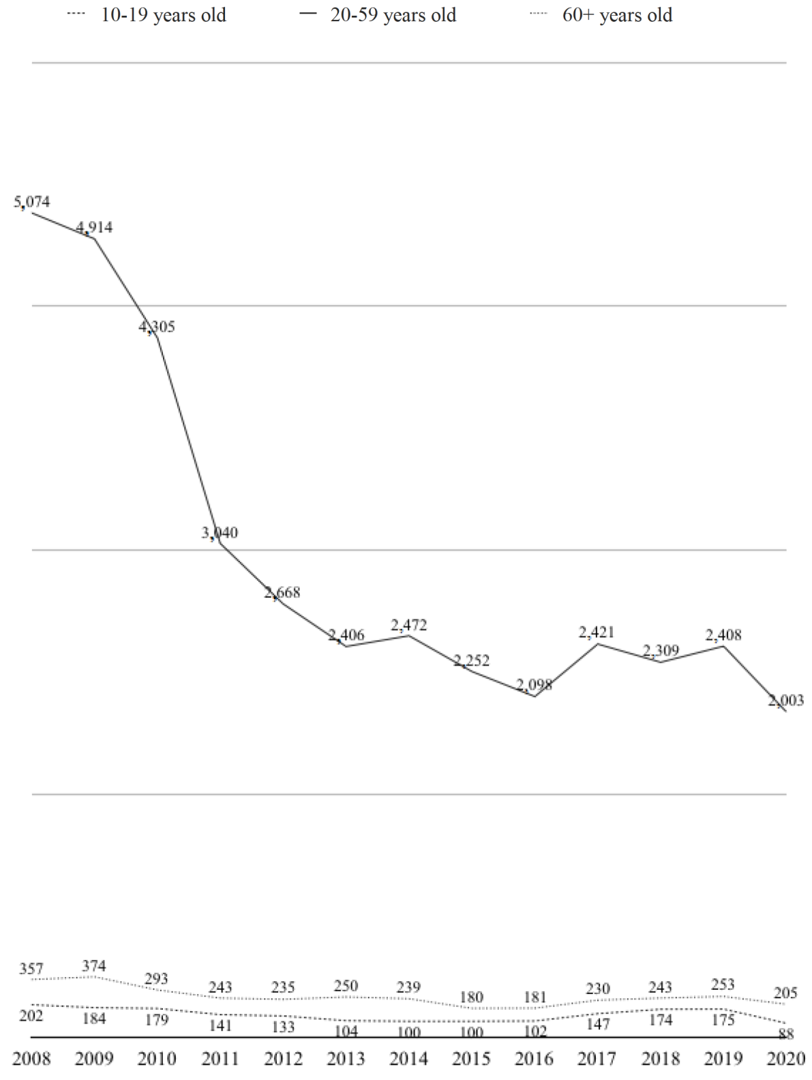
Graph 1 - Number of hospitalizations related to mental/behavioral disorders according to age group. Piauí, PI, Brazil, 2008 - 2020
Source: The authors (2021). Data from the SUS Hospital Information System (SIH/SUS)
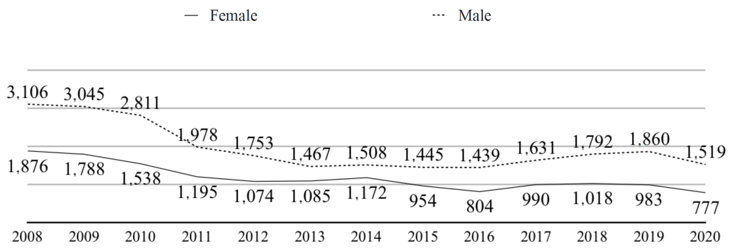

Graph 2 - Number of hospitalizations related to mental/behavioral disorders according to gender. Piauí, PI, Brazil, 2008 - 2020
Source: The authors (2021). Data from the SUS Hospital Information System (SIH/SUS)

The number of hospitalizations also decreased as the years went by, regardless of gender. The number of hospitalizations among men was higher in the entire historical series: 25,354 (62.4%) corresponded to the male gender. The difference was higher in 2010 (33.6%) and lower in 2014 (12.3%) (Graph 2). Table 1 and Graphs 1 and 2 show an increase in the number of hospitalizations from 2016 to 2019, a behavior that differs from the drop recorded from 2009.

DISCUSSION
According to the World Health Organization (WHO), in 2011, the prevalence of mental disorders in the world population was around 10%, exceeding 25% when considering episodes throughout life⁸. More frequent hospitalizations in the capital or in reference cities of the macro-region are expected data and corroborate the findings of a study⁹ carried out in Ceará: most of the hospitalizations occur in the capital city (87.2%) and 12.8% are distributed across other regions of the state.
It is a reasonable assumption that the increase in primary care offer and coverage would allow a greater number of users in psychological distress to have access to health and treatment services and, less frequently, to be referred for hospitalization¹⁰. In some clinical conditions, hospitalization can also be considered necessary for the remission of symptoms and for health improvements, with the hospital considered as a place that provides comprehensive care, similar to that offered in community-based services, although in an intensive way, due to the users' need¹¹.
The increase in the number of hospitalizations can be related to a phenomenon called “revolving door”¹², which occurs due to frequent readmissions, related to lack or insufficiency of substitutive and community services and to the difficulty adhering to drug and/or outpatient treatments, especially after hospitalization, which is sometimes the gateway to mental health care. This is a reflection of the weakness of the health systems to coordinate the assistance to be provided and offer support in the transitions between hospitals and other services¹³.
Even in other regions of the country, the mean hospitalization cost and time are similar to those found in Piauí. In Florianópolis, the cost to keep a patient hospitalized is R$ 1,227.06¹⁴ and in Rio Grande do Sul, the mean hospitalization time was 28.1 days in 2001¹⁵. In the capitals, the out-of-hospital care network is comprehensive and this favors the hospital discharge process, providing more safety to the patient's transition to external services¹⁶. The RAPS networks from Teresina and Parnaíba have more care-related equipment than Picos, which can explain the shorter hospitalization periods. It is verified that out-of-hospital care networks with limited coverage imply longer psychiatric hospitalization times.
The fact that hospitalization is used as a gateway to care can be related to the culture that has been established about hospitalization as a traditional and resolute treatment for mental disorders, with the hospital-centered logic prevailing, based on the explanatory model of the biomedical -disease process. There is a frequent discourse among users and family members in which hospitalization appears as the best treatment modality, in addition to reports of lack of knowledge about other RAPS services¹³.
The results point to the need to value and intensify care based on the biopsychosocial model. Although the absolute cost of hospital and community care is sometimes similar, the range of possible interventions in primary care carried out in the community is effective both in maintaining these people in society and in social reintegration, which suggests that these interventions are highly cost-effective when compared to segregation in the hospital context¹⁷.
The reduction in the number of hospitalizations in the state from 2009 to 2012 is a reflection of the closing, in 2009, of an important psychiatric hospital: Sanatório Meduna, located in the capital city. Prior to the official communication of the closure to the Public Ministry, there was a reduction in the institution's beds, which led to collapse of its operation. Even with the reduction in the number of beds, the RAPS from the capital city lacked due conditions to offer the necessary support to the patients that remained hospitalized¹⁸.
In 2010, commitments were signed for the maintenance of study and municipal subsidies to Sanatório Meduna, implementation of three types of CAPS and two Therapeutic Residency Services, creation of a municipal mental health management, opening of a referral service for alcohol and other drugs at the Mocambinho Hospital (capital), opening of beds in general hospitals for patients with chemical dependence, creation of a ward for crisis care at the Areolino de Abreu Hospital, and opening of a CAPSad in Floriano (inland of the state). Thus, closure of Sanatório Meduna, with a previous reduction in the number of beds, and the implementation of these strategic actions contributed to the subsequent strengthening of the RAPS in the capital city, which accounts for almost all the psychiatric hospitalizations, as well as a drastic reduction in the number of hospitalizations in the period from 2009 to 2012¹⁸.
In relation to the number of hospitalizations, the literature points to a higher frequency among users with schizophrenia as a result of the distress generated by the symptoms¹⁹. Such distress makes some users choose psychiatric hospitalizations, seeking some way to alleviate it. Others consider hospitalization as a way to distance from some addictions and to contain their aggressiveness^{11,13,20}.
Dementia syndromes have a high cost for monitoring, as they involve expenditures on medication and hospitalizations, being the disorder with the highest psychiatric mortality rate and the fifth cause of hospitalization²¹. The hospitalization cost in psychiatric institutions is 41% higher than the actual cost for the same procedure in the other hospitals¹⁴. There is also prolonged hospitalization time in the institution, as is the case of patients with the ICD-10 code indicative of mental retardation.
It is observed that, as of 2012 (publication of the Ordinance that established the RAPS), the frequency of hospitalizations presents negligible alterations among adults until the last year of the historical series. One of the reasons for the discontinuity in the reduction trend (with the exception of 2016-2019) is the difficulty inserting mental health in primary care. On certain occasions, the Family Health teams are unprepared to meet mental health demands and find it difficult to collaborate with the reduction in the number of hospitalizations resulting from mental disorders²¹.
Not only in Piauí but also throughout Brazil, hospitalizations due to mental/behavioral disorders are more frequent among men^{13,22}. The international literature also points out the same result²³. This scenario is strongly suggestive of the inclusion of a greater number of individuals in the list of users of the public system, which demanded hospital care, in parallel to the advances of women's emancipation movements, which began to be inserted in the public scene, especially in the mental health care circles¹⁵.
The increase in the number of hospitalizations, regardless of age group and gender, recorded from 2016 onwards, occurred even after the creation, in 2014, of the Deinstitutionalization Program, a RAPS strategy²⁴. It seems to be a reflection of the setbacks in the National Mental Health Policy in the 2016-2019 period. During this period, regulations issued by the federal government encouraged psychiatric hospitalization, which shows a stagnation tendency in the pace of implementation of community-based services²⁵.
In 2017, Resolution No. 32 of the Tripartite Intermanager Commission (Comissão Intergestores Tripartite, CIT) established the (new) guidelines for the functioning of the RAPS²⁶: psychiatric hospitals as an integral care component in the network, in addition to pointing to greater funding for them. In the same year, Ministry of Health Ordinance No. 3,588 was published, which established the Psychosocial Care Center for Alcohol and Other Drugs IV (Centro de Atenção Psicossocial Álcool e Outras Drogas, CAPSad IV)²⁷, which distorts the care logic of the CAPS, as it is an assistance service for urgencies and emergencies, to the detriment of attention to the crisis based on the therapeutic bond²⁵. In 2019, Technical Note No. 11/2019-CGMAD/DAPES/SAS/MS was published as the “New National Mental Health Policy”²⁸, questioning the effectiveness of the model in force until 2017 and the direction of a policy based on community care, in addition to asserting the need to increase the number of psychiatric beds.
As a limitation of this study, the use of secondary data from the SIH/SUS is pointed out, which can represent an underestimated analysis in the absence of data submission and in any of the selected periods. Although data from governmental databases are frequently used for planning, management assessment and in research, it is known that filling out documents that generate this diverse information requires knowledge. In addition to that, such documents, herein translated into the Hospital Admission Authorization (Autorização de Internação Hospitalar, AIH), which generates these data, are valid for 30 days²⁹, with the possibility of influencing the count of hospitalizations³⁰, especially those in which the causes analyzed required longer than that, such as schizophrenia and mental retardation.

CONCLUSION
In Piauí, the number of psychiatric hospitalizations presented a marked reduction from 2009 to 2012 and a discrete drop between 2013 and 2015, the period after enactment of Ordinance No. 3,088/2011. The exception occurred from 2016 to 2019, when regulations were published to encourage psychiatric hospitalization. Male gender and age group between 20 and 59 years old presented a higher frequency of hospitalizations. The hospitalizations were mainly in people with schizophrenia and mood (affective) disorders, diagnoses that demanded higher costs, together with dementia. Mental retardation prolonged the hospitalization times.
This study contributes to the analysis of data that reflect the implementation of previous public policies aimed at mental health and allow planning of health strategies for Piauí, related to the mental health demands and, specifically, to strengthening of the RAPS. There is an evident need for investments in community-based services and for a better articulation between the mental health and primary care devices. Such actions can contribute to reducing the psychiatric hospitalization rates. The results showed the importance of intensifying investments in the out-of-hospital network, for monitoring users with severe and persistent mental disorders, such as those with schizophrenia, mental retardation and mood disorders.

REFERENCES

1. Ministério da Saúde (BR). Reforma psiquiátrica e política de saúde mental no Brasil. Documento apresentado à Conferência Regional de Reforma dos Serviços de Saúde Mental: 15 anos depois de Caracas. [Internet] Brasília: OPAS; 2005 [accessed on 12 jun 2021]. Available in: http://bvsms.saude.gov.br/bvs/publicacoes/Relatorio15_anos_Caracas.pdf.

2. Clementino FS, Miranda FAN, Pessoa Júnior JM, Marcolino EC, Silva Júnior JA, Brandão GCG. Atendimento integral e comunitário em saúde mental: avanços e desafios da Reforma Psiquiátrica. Trab. Educ. Saúde. [Internet]. 2019 [accessed on 25 may 2022]; 17(1). Available in: https://doi.org/10.1590/1981-7746-sol00177.

3. Ministério da Saúde (BR). Portaria Nº 3.088, de 23 de dezembro de 2011. Institui a Rede de Atenção Psicossocial para pessoas com sofrimento ou transtorno mental e com necessidades decorrentes do uso de crack, álcool e outras drogas, no âmbito do Sistema Único de Saúde (SUS). [Internet] Brasília: Ministério da Saúde; 2011 [accessed on 12 jun 2021]. Available in: https://bvsms.saude.gov.br/bvs/saudelegis/gm/2011/prt3088_23_12_2011_rep.html.

4. Campos RTO. Saúde mental no Brasil: avanços, retrocessos e desafios. Cad. Saúde Pública. [Internet]. 2019 [accessed on 25 may 2022]; 35(11). Available in: https://doi.org/10.1590/0102-311X00156119.

5. Presidência da República (BR). Lei Nº 10.216, de 6 de abril de 2001. Dispõe sobre a proteção e os direitos das pessoas portadoras de transtornos mentais e redireciona o modelo assistencial em saúde mental. [Internet] Brasília; 2001 [accessed on 30 mar 2021]. Available in: http://www.planalto.gov.br/ccivil_03/leis/leis_2001/l10216.htm.

6. Silva MAP da, Giacon-Arruda BCC, Marcheti PM, Teston EF, Veivenberg CG, Lima H de P. Bordando saúde: percepção de mulheres em sofrimento psíquico sobre a vivência em uma oficina terapêutica. Cogitare Enferm. [Internet]. 2022 [accessed on 25 may 2022]; 27. Available in: https://revistas.ufpr.br/cogitare/article/view/81933.

7. Almeida JMC de. Política de saúde mental no Brasil: o que está em jogo nas mudanças em curso. Cad. Saúde Pública. [Internet]. 2019 [accessed on 25 may 2022]; 35(11). Available in: https://doi.org/10.1590/0102-311X00129519.

8. World Health Organization (WHO). Mental health and older adults. [Internet]. Geneva: WHO; 2016 [accessed on 10 jun 2021]. Available in: http://www.who.int/mediacentre/factsheets/fs381/en/.

9. Melo MCA, Albuquerque SGC, Luz JHS, Quental PT de LF, Sampaio AM, Lima AB. Perfil clínico e psicossocial dos moradores em hospitais psiquiátricos no estado do Ceará, Brasil. Ciência & Saúde Coletiva. [Internet]. 2015 [accessed on 07 jun 2021]; 20(2). Available in: https://doi.org/10.1590/1413-81232015202.2062013.

10. Miliauskas CR, Faus DP, Junkes L, Rodrigues RB, Junger W. Associação entre internações psiquiátricas, cobertura de CAPS e atenção básica em regiões metropolitanas do RJ e SP, Brasil. Ciência & Saúde Coletiva. [Internet]. 2019 [accessed on 12 jun 2021]; 24(5). Available in: https://doi.org/10.1590/1413-81232018245.18862017.

11. Pereira AR, Joazeiro G. Percepção da internação em hospital psiquiátrico por pacientes com diagnóstico de esquizofrenia. O Mundo da Saúde. [Internet]. 2015 [accessed on 06 jun 2021]; 39(4). Available in: https://doi.org/10.15343/0104-7809.20153904476483.

12. Giovanni P Di, Martino G Di, Zecca IAL, Porfilio I, Romano F, Staniscia T. The revolving door phenomenon: psychiatric hospitalization and risk of readmission among drug-addicted patients. Clin. Ter. [Internet]. 2020 [accessed on 25 may 2022]; 171(5). Available in: https://pubmed.ncbi.nlm.nih.gov/32901786/.

13. Zanardo GL de P, Silveira LH de C, Rocha CMF, Rocha KB. Internações e reinternações psiquiátricas em um hospital geral de Porto Alegre: características sociodemográficas, clínicas e do uso da Rede de Atenção Psicossocial. Rev. bras. epidemiol. [Internet]. 2017 [accessed on 12 jun 2021]; 20(3). Available in: https://doi.org/10.1590/1980-5497201700030009.

14. Lindner LM, Marasciulo AC, Farias MR, Grohs GEM. Avaliação econômica do tratamento da esquizofrenia com antipsicóticos no Sistema Único de Saúde. Rev. Saúde Pública. [Internet]. 2009 [accessed on 01 jun 2021]; 43(Supl. 1). Available in: https://doi.org/10.1590/S0034-89102009000800010.

15. Horta RL, Costa JSD da, Balbinot AD, Watte G, Teixeira VA, Poletto S. Hospitalizações psiquiátricas no Rio Grande do Sul de 2000 a 2011. Rev. bras. epidemiol. [Internet]. 2015 [accessed on 07 jun 2021]; 18(4). Available in: https://doi.org/10.1590/1980-5497201500040019.

16. Lara APM, Volpe FM. Evolução do perfil das internações psiquiátricas pelo Sistema Único de Saúde em Minas Gerais, Brasil, 2001-2013. Ciênc. saúde colet. [Internet]. 2019 [accessed on 06 jun 2021]; 24(2). Available in: https://doi.org/10.1590/1413-81232018242.14652017.

17. Gonçalves RW, Vieira FS, Delgado PGG. Política de Saúde Mental no Brasil: evolução do gasto federal entre 2001 e 2009. Rev. Saúde Pública. [Internet]. 2012 [accessed on 01 jun 2021]; 46(1). Available in: https://doi.org/10.1590/S0034-89102011005000085.

18. Macedo JP, Dimenstein M. A reforma psiquiátrica em contextos periféricos: o Piauí em análise. Memorandum: Memória e História em Psicologia. [Internet]. 2012 [accessed on 30 may 2021]; 22. Available in: https://periodicos.ufmg.br/index.php/memorandum/article/view/6595.

19. Moniz ASB, MRS da, Devos ELB, Lourenção LG. Perfil de usuários e familiares de serviço psiquiátrico de Cabo Verde – África. Cogitare enferm. [Internet]. 2019 [accessed on 25 may 2022]; 24. Available in: https://dx.doi.org/10.5380/ce.v24i0.59756.

20. Hiany N, Vieira MA, Gusmão ROM, Barbosa SF. Perfil epidemiológico dos transtornos mentais na população adulta no Brasil: uma revisão integrativa. Rev. Enferm. Atual In Derme [Internet]. 2020 [accessed on 25 may 2022]; 86(24). Available in: https://www.revistaenfermagematual.com.br/index.php/revista/article/view/676.

21. Santos VC, Anjos KF dos, Boery RNS de O, Moreira RM, Cruz DP, Boery EN. Internação e mortalidade hospitalar de idosos por transtornos mentais e comportamentais no Brasil, 2008-2014. Epidemiol. Serv. Saude. [Internet]. 2017 [accessed on 14 jun 2021]; 26(1). Available in: https://doi.org/10.5123/S1679-49742017000100005.

22. Bibiano AMB, Moreira RS, Oliveira MMG de, Silva VL. Fatores associados à utilização dos serviços de saúde por homens idosos: uma revisão sistemática da literatura. Ciência & Saúde Coletiva. [Internet]. 2019 [accessed on 25 may 2022]; 24(6). Available in: https://doi.org/10.1590/1413-81232018246.19552017.

23. Rezaian MK, Rahmani A, Mohaneri F, Moghadam HK. Epidemiology of psychiatric disorders: the situation of Mashhad city during 2010-2016. Journal of Fundamentals of Mental Health. [Internet]. 2017 [accessed on 14 jun 2021]; 19(6). Available in: https://doi.org/10.22038/JFMH.2017.9557.

24. Ministério da Saúde (BR). Portaria Nº 2.840, de 29 de dezembro de 2014. Cria o Programa de Desinstitucionalização integrante do componente Estratégias de Desinstitucionalização da Rede de Atenção Psicossocial (RAPS), no âmbito do Sistema Único de Saúde (SUS), e institui o respectivo incentivo financeiro de custeio mensal. [Internet] Brasília: Ministério da Saúde; 2014 [accessed on 14 de jun 2021]. Available in: https://bvsms.saude.gov.br/bvs/saudelegis/gm/2014/prt2840_29_12_2014.html.

25. Cruz NF de O, Gonçalves RW, Delgado PGG. Retrocesso da reforma psiquiátrica: o desmonte da política nacional de saúde mental brasileira de 2016 a 2019. Trab. educ. saúde. [Internet]. 2020 [accessed on 14 jun 2021]; 18(3). Available in: https://doi.org/10.1590/1981-7746-sol00285.

26. Ministério da Saúde (BR). Resolução Nº 32, de 14 de dezembro de 2017. Estabelece as Diretrizes para o Fortalecimento da Rede de Atenção Psicossocial (RAPS). [Internet] Brasília: Diário Oficial da União; 2017 [accessed on 14 jun 2021]. Available in: https://portalarquivos2.saude.gov.br/images/pdf/2018/janeiro/05/Resolu----o-CIT-n---32.pdf.

27. Brasil. Ministério da Saúde. Portaria Nº 3.588, de 21 de dezembro de 2017. Altera as portarias de consolidação Nº 3 e Nº 6, de 28 de setembro de 2017, para dispor sobre a Rede de Atenção Psicossocial, e dá outras providências. [Internet]. Brasília: Ministério da Saúde; 2017 [accessed on 14 jun 2021]. Available in: http://bvsms.saude.gov.br/bvs/saudelegis/gm/2017/prt3588_22_12_2017.html.

28. Ministério da Saúde (BR). Nota técnica Nº 11/2019-CGMAD/DAPES/SAS/MS. Esclarecimentos sobre as mudanças na Política Nacional de Saúde Mental e nas Diretrizes da Política Nacional sobre Drogas. [Internet] Brasília: Ministério da Saúde; 2019 [accessed on 14 jun 2021]. Available in: https://pbpd.org.br/wp-content/uploads/2019/02/0656ad6e.pdf.

29. Dias BM, Badagnan HF, Marchetti SP, Zanetti ACB. Gastos com internações psiquiátricas no estado de São Paulo: estudo ecológico descritivo, 2014 e 2019. Epidemiol. Serv. Saude. [Internet]. 2021 [accessed on 25 may 2022]; 30(2). Available in: https://doi.org/10.1590/S1679-49742021000200024.

30. Yano KM, Prado SI, Couto W, Zucchi P, Novaes MAP de. Limitações no uso do DATASUS como fonte de dados de pesquisas científicas. Revista Multidisciplinar Em Saúde. [Internet]. 2021 [accessed on 25 may 2022]; 2(4). Available in: https://doi.org/10.51161/rems/2780.

